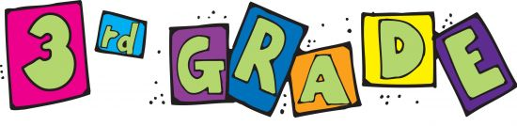

Welcome to 3rd grade, it’s going to be a great year! As we start the year as 3rd graders there are a few supplies we will need. The following is a list of supplies you will need to bring to the first day of school.
16 large glue sticks
3 boxes of 12 pencils (pre-sharpened, if possible)
4 black dry erase markers
4 pink or white rectangle erasers
1 pair of scissors
2 boxes of Crayola crayons (24 pack)
1 pack of Crayola colored pencils
Post-it notes
Earbuds/headphones
1 10 or 12 pack of thick Crayola markers
3 plastic 2-pocket folders (green, blue, red)
2 folders of their choosing
1 soft pencil case (pouch)
2 boxes of tissues
2 composition notebooks
2 thin black Sharpies
1 JUMBO book sock
1 regular book sock

Thank you,
Ms. Piccinich

